Kodu: Increasing Girls’ and Boys’ Interest in
Computer Science through Video Game Authorship
Joshua A. Tabak*  Department of Psychology  University of Washington  Seattle, WA 98195-1525 USA  tabak@uw.edu | Kathryn T. Stolee*  Department of Computer Science & Engineering  University of Nebraska—Lincoln  Lincoln, NE 68588-0115 USA  kstolee@cse.unl.edu

ABSTRACT
*Work completed while affiliated with Microsoft FUSE Labs.
Although multiple programming languages have been designed for child users, it is largely unknown whether children’s use of such languages impacts their interest in and attitudes towards computer science. Kodu, by Microsoft FUSE Labs, is a visual programming language targeting users of all ages – including children – that allows its users to create video games and animations. In a 9-hour user experience study, children learned to program in Kodu and created their own video games. We found that the Kodu experience led children to report increased (a) interest in computer science and (b) sense of fit, or belonging, with computer programmers. These findings indicate that teaching programming from a young age and using a novice-friendly platform such as Kodu may help encourage youth to explore technical fields. Moreover, despite gender differences in average levels of interest in and sense of fit with computer science, these results held for both boys and girls. This implies that involving young girls in educational interventions using programming languages like Kodu may be an effective strategy for combating women’s underrepresentation in computer science.

Author Keywords
Education, children, programming languages, video games, user experience study.

ACM Classification Keywords
K3.2. Computing Milieux: Computer and Information Science Education – Computer Science Education.

INTRODUCTION
Successful entry into the field of Computer Science (CS) generally requires early technical experience and coursework completion [6]. Accordingly, exposing children to CS experiences would likely maximize individuals’ opportunities to explore the field of CS, and may lead to increased participation in the field. Although several programming languages, such as Scratch [8] and Storytelling Alice [3], have been developed (a) specifically for tech-novices such as children and (b) with the goal of increasing children’s interest in CS, it remains largely unknown whether experience with such programming languages actually increases children’s interest in CS. Here, we address this issue.
In addition to assessing whether programming experience increases children’s interest in CS, we investigated whether programming experience could increase children’s sense of fit with the field of CS, as psychological sense of fit or belonging in a domain is an impactful factor in educational and occupational choices [2].

Kodu and Education
To evaluate the effects of programming experience on children’s interest in and attitudes towards CS, we invited children (ages 9-12) to participate in an instructional user experience study with Kodu Game Lab (Kodu) [4, 5]. Kodu, available for PC or XBOX 360, is an educational video game lab – a video game for creating video games. It uses a high-level, visual and interpreted language that allows users to define behavior of individual characters using when – do rules (when condition – do action) [9], making it ideal for educational interventions targeting tech-novices such as children. The condition and action are each composed of zero or more tiles, the building blocks of programming rules. Figure 1 shows an example of the programming interface for a particular character in Kodu, and illustrates the visual nature of the language and programming interface. For instance, the first programming rule (first line of tiles in Figure 1) reads, when keyboard left-arrow, do move west quickly quickly. This means that when the left arrow on the keyboard is pressed, the character has been instructed to move doubly-quickly in the direction of cardinal west.

Figure 1. Example of Kodu’s language
and programming interface.
As a game lab, Kodu is not a video game in the traditional sense. There are several activities that users engage in while using Kodu, including designing the world for a game, adding and editing character properties, programming character behavior, and playing games. Accordingly, Kodu is less a game and more a creative medium through which users can design and program their own video games. This makes Kodu uniquely suited for use in educational settings because users could be instructed to program certain types of games depending on what concepts instructors wish to convey to their students. The fact that video game use pervades childhood for many youth provides an additional advantage in that children are likely to be familiar with the types of user interfaces implemented in Kodu. Teaching children how to program using a medium that is comfortable for both boys and girls (e.g., Kodu) may help avoid gender gaps in participation; not all programming environments are equally amenable to use by both genders [1].
These theoretical and practical motivations provide the foundation for the present study of the social psychological effects of learning to program in Kodu. We aim to address the following research questions:
- After gaining programming experience in Kodu, how will children’s reports of interest in CS change?
- After gaining programming experience in Kodu, how will children’s reports of sense of fit with programmers change?
- How is a child’s sense of fit with computer programmers related to the child’s interest in programming?

METHOD
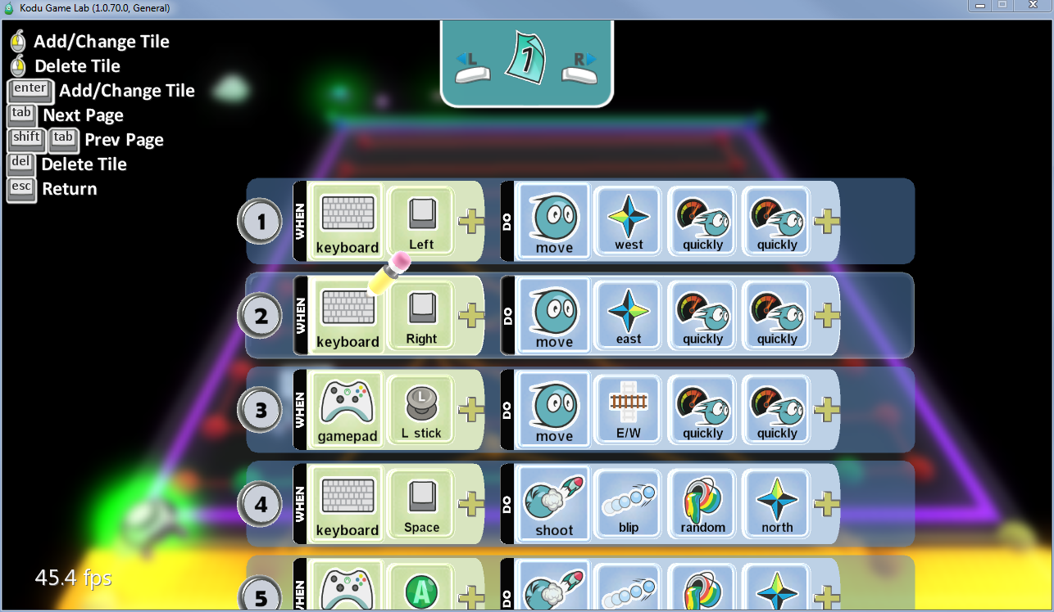
To address our research questions, we launched an empirical user study that introduced children to Kodu Game Lab in a series of three 3-hour sessions. We surveyed participants’ interest in and perceptions of computer science and programmers before the first and after the final session.

Participants
To recruit child participants, we advertised the Kodu workshop using a mailing list of parents interested in Kodu. Thirty-one children (9 girls) between the ages of 9 and 12 volunteered to participate, with parental consent.

Apparatus
Kodu Game Lab 1.0.71 was run on Windows 7-based PCs. Each PC was equipped with a standard computer keyboard, mouse, and an XBOX 360 gamepad controller. On the PC, Kodu can be operated using either keyboard and mouse or XBOX gamepad controller; during the study, all instructions referenced the gamepad, but users were not restricted from using the keyboard or mouse.

Curriculum
Over the course of the Kodu user study, children were guided through a series of activities in Kodu. These activities involved the following tasks:
- Programming characters’ automatized behaviors using Kodu’s programming interface and the when – do syntax. (E.g., when bump apple, do eat it.)
- Creating landscapes using Kodu’s terrain tools.
- Applying programming rules to allow characters to respond to user input. (E.g., see Figure 1.)
- Using complex character properties and world properties to model program state, such as timers, health monitors, colors, and scores.
The curriculum was designed to give children the tools needed to create a moderately sophisticated Kodu game.

Procedure
Participants attended the Kodu study sessions on three consecutive mornings or afternoons, and each session was three hours long. Each session included some instructional time during which a session leader demonstrated how to perform the activities in the curriculum using Kodu (see foregoing section on curriculum) and free time for children to practice programming in Kodu. Session leaders were available to answer children’s questions during the sessions, and children were permitted to interact with each other.
At the beginning of the first session, children were asked to complete a pre-test survey in which they reported their attitudes toward and opinions of programming, programmers, CS, and Kodu. At the conclusion of the third (final) session, children were asked to complete a post-test survey, which included content from the pre-test survey as well as demographic questions. To encourage the children to create interesting programs and go beyond what the session leaders demonstrated, the children were asked to present their games at the end of the third session. Observation by session leaders indicated that this was an adequate measure for eliciting active participation and creative exploration during the workshop.
Figure 2. Interest in CS as a function of gender and time. Main effects of gender and time were statistically significant; there was no statistically detectable interaction.
* simple effect p < .05
*
*
*
*

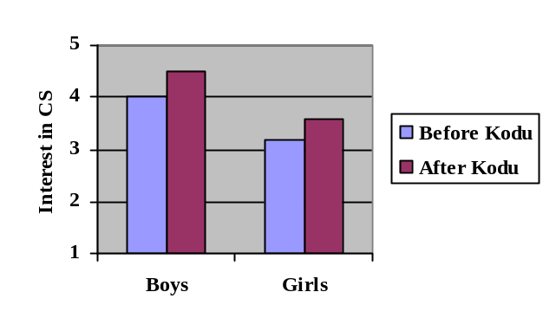Survey Materials
At both pre-test and post-test, participants responded to a series of statements using a 5-point Likert scale with the anchors 1 = completely untrue and 5 = completely true. There were three general groupings of questions. The first group of items measured general attitudes towards CS and programming (e.g., “I am interested in computer programming,” “I feel like I fit in with computer programmers”). The second group of items measured participants’ perceptions of computer programmers by indicating how untrue or true a series of adjectives (e.g., smart, cool, geeky) were of computer programmers. The final group of items measured attitudes towards programming in Kodu (e.g., “I think programming a video game in Kodu [will be/was]…” “fun,” “easy”). Items germane to the present paper are all listed explicitly in the following sections.

Results and Discussion
Here, we explore the results of the surveys to address our research questions.

Interest in Computer Science
Interest in CS (RQ1) was measured by a composite of three intercorrelated items (“I am interested in computer programming,” “I would like to be a computer programmer someday,” and “I could be good at computer programming”) that demonstrated good internal consistency (Cronbach’s α = .75 at pretest; α = .84 at post-test). To investigate differences in interest in CS as a function of programming in Kodu and gender, interest in CS was subjected to a repeated-measures analysis of variance (ANOVA) with time (pre- vs. post-test) as the within-participant factor and gender as the between-participants factor. As depicted in Figure 2, a main effect of time indicated that, collapsing across gender, interest in CS significantly increased between pre-test (Mean = 3.59) and post-test (Mean = 4.05), F_{1, 29} = 15.77, p < .001, η²_{p} = .35. A main effect of gender indicated that, collapsing across time, boys (Mean = 4.25) were more interested in CS than were girls (Mean = 3.39), F_{1, 29} = 14.92, p < .001, η²_{p} = .34.
Figure 3. Sense of fit with CS as a function of gender and time. Main effects of gender and time were statistically significant; there was no statistically detectable interaction.
* simple effect p < .05
Importantly, there was no evidence of a time × gender interaction, F_{1, 29} < 1, indicating that the main effect of time operated similarly regardless of gender. Indeed, the simple effect of time was statistically significant both for girls alone (p = .043) and for boys alone (p < .001).
Together, this pattern of results is consistent with our hypothesis that gaining programming experience in Kodu increases children’s interest in CS. In line with national trends [7], boys (vs. girls) reported stronger interest in CS, overall (main effect of gender). More interestingly, participants were more interested in CS after having used Kodu (main effect of time), and the impact of Kodu on interest in CS did not vary as a function of gender (i.e., no time × gender interaction).

Sense of Fit with Programmers
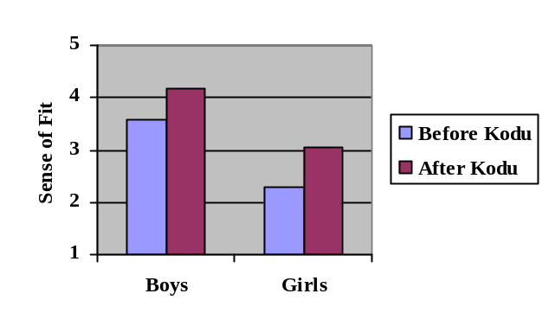Fit with programmers (RQ2) was measured by the item, “I feel like I fit in with computer programmers.” To investigate differences in sense of fit as a function of programming in Kodu and gender, fit with programmers was subjected to a repeated-measures ANOVA with time (pre- vs. post-test) as the within-participant factor and gender as the between-participants factor. As depicted in Figure 3, a main effect of time indicated that, collapsing across gender, fit with programmers significantly increased between pre-test (Mean = 2.93) and post-test (Mean = 3.62), F_{1, 29} = 18.38, p < .001, η²_{p} = .39. A main effect of gender indicated that, collapsing across time, boys (Mean = 3.89) reported stronger fit with programmers than did girls (Mean = 2.67), F_{1, 29} = 23.03, p < .001, η²_{p} = .44. There was no evidence of a time × gender interaction, F_{1, 29} < 1, indicating that the main effect of time operated similarly regardless of gender. Indeed, the simple effect of time was statistically significant both for girls alone (p = .007) and for boys alone (p = .002).
Participants’ sense of fit with programmers was also measured by the item, “I am similar to people who are really good with computers and technology.” Analysis of this item yielded results of the same pattern reported for fit.
As with interest in CS, these results supported our prediction that gaining programming experience in Kodu would increase children’s reports of fit with programmers, an important factor in educational and occupational choices.

The Relationship between Sense of Fit and CS Interest
The relationship between sense of fit and CS interest (RQ3) was measured by correlating sense of fit with the composite variable, CS interest. Boys’ sense of fit with programmers was directly correlated with their interest in CS, both at pre-test (r₂₂ = .57, p < .01) and post-test (r₂₂ = .50, p = .02).
Girls’ sense of fit with programmers was unrelated to their interest in CS at pre-test (r₉ = .09, p = .81); this unexpected null correlation should be interpreted with caution until it can be replicated. As expected, at post-test, girls’ sense of fit with programmers was strongly correlated with their interest in CS (r₉ = .80, p < .01).
Overall, these correlations are consistent with our hypothesis that people’s sense of fit with CS predicts their interest in CS, replicating previous work [2].

General Discussion
In this work, we examined how children’s interest in and attitudes towards computer science changed after learning to program in an educational visual programming environment. Although several programming languages have been developed specifically for teaching children how to program, the social psychological effects of learning such languages have remained largely unknown.
We found that as a result of learning how to program in Kodu and having time to freely explore the Kodu Game Lab, children’s attitudes changed in interesting and important ways. After learning how to program in Kodu, children – both boys and girls – reported increased interest in CS and a higher sense of fit with computer programmers.
The findings that learning Kodu increased interest in and sense of fit with CS indicate that teaching programming languages such as Kodu to children may be a promising method for increasing children’s participation in CS. These findings are particularly noteworthy because they applied to both boy and girl participants. Finding ways to alter the image of CS to make it more welcoming to females will be key in efforts to combat women’s underrepresentation in CS [2]. This research suggests that involving girls in creative programming endeavors from a young age, such as programming video games in Kodu, may help develop an image of CS as welcoming to women.

Conclusion and Future Directions
Kodu is a video game lab; that is, a video game for creating video games. Kodu’s language and programming interface are entirely graphical in nature, making Kodu ideal for use with tech-novices such as children. Here, we demonstrated that teaching children basic Kodu programming techniques and giving children some free time to program in Kodu – in a total of fewer than 10 hours of time – was a sufficiently powerful experience to increase children’s interest in CS and sense of fit with programmers.
Going forward, it will be valuable to examine the mechanisms underlying this effect. For example, what specifically led to children’s increased interest in CS? Given the design of the current study, it could have been, e.g., experience with Kodu, interactions with the session leaders, a combination, or some other factors. Future experiments with random assignment to Kodu or control conditions will help disentangle these possible explanations and better our understanding of the observed phenomena.

ACKNOWLEDGMENTS
We thank Rachel Schiff, Stephen Coy, Nicholas Boss, Julian Boss, Daryl Zuniga, Teale Fristoe, Amy Sorokas, Elizabeth Bennett, Bradley Gibson, Eric Anderson, Lili Cheng, Kristin Stecher, and Matthew MacLaurin for their assistance with data collection, Kodu development, or both. We also thank Sapna Cheryan for methodological feedback.

REFERENCES
- Burnett, M., Fleming, S.D., Iqbal, S., Venolia, G., Rajaram, V., Farooq, U., Grigoreanu, V., and Czerwinski, M. Gender differences in programming environments: Across programming populations. In Proc. ESEM 2010, ACM Press (2010).
- Cheryan, S., Plaut, V.C., Davies, P.G., and Steele, C.M. Ambient belonging: How stereotypical cues impact gender participation in computer science. J. Personality and Social Psychology 97, 6 (2009), 1045-1060.
- Kelleher, C., Pausch, R., and Kiesler, S. Storytelling Alice motivates middle school girls to learn computer programming. In Proc. CHI 2007, ACM Press (2007), 1455-1464.
- Kodu Game Lab. http://fuse.microsoft.com/project/kodu.aspx
- MacLaurin, M. Kodu: End-user programming and design for games. In Proc. FDG 2009, ACM Press (2009), xviii-xix.
- Moses, M.S., Howe, K.R., and Niesz, T. The pipeline and student perceptions of schooling: Good news and bad news. Educational Policy 13, 4 (1999), 573-591.
- National Science Foundation. Women, minorities, and persons with disabilities in science and engineering (2008). http://nsf.gov/statistics/wmpd/pdf/tabc-4.pdf
- Resnick, M., Maloney, J., Monroy-Hernandez, A., Rusk, N., Eastmond, E., Brennan, K., Millner, A., Rosenbaum, E., Silver, J., Silverman, B., and Kafai, Y. Scratch: Programming for all. Commun. ACM 52, 3 (Nov. 2009), 60-67.
- Stolee, K.T. Kodu language and grammar specification. Microsoft Research whitepaper, September 2010.

